- Department of Marine Sciences, University of Puerto Rico-Mayagüez, Marine Geology Lab, Isla Magueyes, Lajas, Puerto Rico 00667

- Puerto Rico Seismic Network, University of Puerto Rico-Mayagüez, Universidad de Puerto Rico Edificio D Mayagüez, Puerto Rico 00680

[elvin.cordero@upr.edu](mailto:elvin.cordero@upr.edu)

Natural Hazards, GIS, Remote Sensing

February 16, 2024

Hazus, Landslide Susceptibility, Earthquake, Risk Analysis

# Introduction

Puerto Rico, a territory characterized by its dynamic geological and seismic activity, stands at the forefront of understanding natural hazards in the Caribbean region. Among these hazards, landslides triggered by seismic events represent a critical intersection of earth surface processes and human vulnerability. This study aims to unravel the complexities of seismically induced landslides in Puerto Rico, providing a comprehensive analysis that bridges the gap between seismology and geomorphology.

The island’s unique geological composition, coupled with its location at the boundary of the North American and Caribbean tectonic plates, predisposes it to frequent seismic activity. These seismic events, ranging from minor tremors to significant earthquakes, possess the potential to destabilize slopes and trigger landslides, posing substantial risks to both the population and infrastructure. The devastating impact of the 2020 southwestern Puerto Rico earthquakes underscores the urgency of assessing landslide susceptibility in a seismically active context.

This paper explores the mechanisms by which seismic forces contribute to slope failure, employing a multidisciplinary approach that combines geotechnical analysis, spatial data modeling, and historical event review. By focusing on seismically induced landslides, the study seeks to incorporating key factors contributing to landslide susceptibility, including seismic intensity, ground motion characteristics, slope angle, lithology, and hydrological conditions. as a proxy for potential soil wetness. Using the Nowicki Jessee et al. (2018) model, landslide susceptibility can be accurately predicted with peak ground velocity (PGV), slope, lithology, land cover, and a compound topographic index (CTI) using the following equation:

Where $a$, $b$, $c$, $d$, $e$, $f$ and $g$ are coefficients solved for within the Nowicki Jessee et al. (2018) model.

The overarching goal is to develop a predictive model for landslide susceptibility in Puerto Rico using the Nowicki Jessee et al. (2018) model. Such a model not only advances our scientific understanding of landslide dynamics but also serves as a crucial tool for disaster risk management, land-use planning, and the development of mitigation strategies to protect vulnerable communities. Through this research, we contribute to a safer and more resilient Puerto Rico, where the risks of seismically induced landslides are understood, anticipated, and managed.

# Methodology

## Study Region

Puerto Rico, along with the Virgin Islands and eastern Hispaniola, exist on a microplate in an active plate boundary zone that lies between the westward-moving North America Plate and the eastward-moving Caribbean Plate, marked by the Anegada Trough and Muertos Trough to the south and the Puerto Rico Trench to the north (O’Loughlin and Lander 2003). There are complex motions occurring between Puerto Rico and the Dominican Republic, where to the south, in Mona Passage and Mona Canyon, there is extension and oblique thrusting, while possible strike-slip motion is happening in the Puerto Rico Trench (Mercado and McCann (1998); Fig. 3). The interpolate motion, running parallel of the Puerto Rico Trench, averages two meters per century and slow subduction zones can generate interpolate-thrust earthquakes and associated tsunamis (Atwater et al. 2014). Mona Canyon is the location of the most important tsunamigenic sources near northwestern Puerto Rico, where the sea floor lies more than 2 km lower than its surrounding due extensional tectonics which has caused the down dropping of large blocks of the inner wall of the trench, resulting in the development of normal faults (Mercado and McCann 1998).

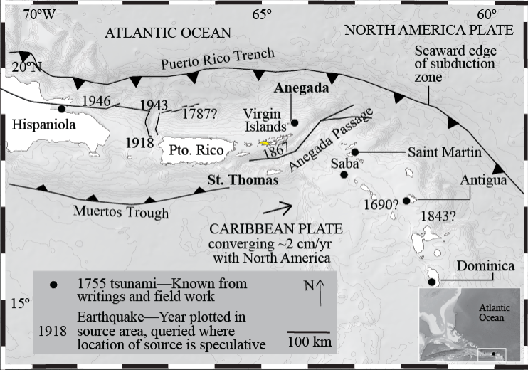

The Puerto Rico-Virgin Islands microplate. Stars represent the four scenarios analyzed by Ramirez-Rivera (2016): 1787 Puerto Rico Trench (1787PRT), 1867 Virgin Islands Basin (1867 VIB), 1918 Mona Canyon (1918 MC), and the hypothetical event 13PR. Source: Ramirez-Rivera (2016), Figure 1.2, pg 6.

## Software

The geospatial processing procedures were completed with the R statistical language (R Core Team 2023) using spatial toolsets such as the *terra* and *tidyterra* packages (Hijmans 2023; Hernangómez 2023). Polygon drafting and editing was done in the QGIS geographic information system software (QGIS Development Team 2024).

## Model Inputs

### Peak Ground Velocity (PGV)

Peak Ground Velocity (PGV) measures the maximum speed at which the ground moves at a location during an earthquake, typically expressed in terms of distance per unit time. It is a critical parameter in seismology and earthquake engineering, indicating the intensity of ground motion and its potential to cause structural damage and induce landslides. PGV is used alongside peak ground acceleration (PGA) and spectral acceleration (SA) in seismic hazard analysis to characterize expected ground shaking, informing the design of earthquake-resistant structures and mitigation strategies. High PGV values are associated with increased risk of severe structural damage and slope failures, making accurate PGV estimation vital for risk assessments, building codes, and the development of earthquake preparedness measures. The PGV modeled for three historical earthquake scenarios were used by Ramírez-Rivera (2016) to estimate earthquake loss; these included the M7.5 Mona Canyon earthquake of 1918, the M7.5 Virgin Island Basin (VIB) earthquake of 1867, and the M~8.0 event that occurred offshore the northern coast of Puerto Rico on May 2, 1787 (Doser et al. 2005). Specified fault geometry and magnitude of the earthquake scenarios from estimates of i) fault dimensions, ii) intensity map, and iii) ground motion were obtained by Ramírez-Rivera (2016) from the literature (Mercado and McCann 1998; Huérfano 2003; Zahibo et al. 2003). The maximum PGV possible at a given location was used for the analysis. This was grouped into equal intervals ranging from 0-5 and >50 cm/s, each assigned a landslide susceptibility score between zero and 10, from none to very high.

### Terrain Analysis

Digital Elevation Models (DEMs) are pivotal in landslide susceptibility analysis, through precise slope gradient calculations and hydrological modeling. DEMs delineate steep terrains at heightened landslide risk and areas susceptible to water-induced soil destabilization. By integrating DEMs with geotechnical data, researchers can quantitatively assess erosion dynamics and structural stability of landforms. The SRTM15+ global bathymetry and topography (15-arc sec resolution) for Puerto Rico was downloaded using the *elevatr* package (Tozer et al. 2019; Hollister et al. 2023). Slope, $α$, was calculated using the Fleming and Hoffer (1979) method and eight neighboring cell. Flow direction of water, $Q_{d}$ for each cell was estimated from the direction of the greatest drop in elevation (Hijmans 2023) and flow accumulation, $A_{s}$, was defined as the sum of flow directions of the surrounding neighbors (Equation ).

With DEM-derived flow accumulation as a proxy for specific basin area and the slope in radians, the compound topography index (CTI) (Moore et al. 1991), also known as the topographical wetness index (TWI), was computed using Equation .

The slope angle (degrees) were given landslide susceptibility scores according to the Nadim et al. (2006) categorization of slope data. The CTI was grouped into equal intervals ranging from 0-5 and >50, each assigned a landslide susceptibility score between zero and 10, from none to very high.

### Land Cover

Land cover significantly influences landslide susceptibility through its modulation of surface hydrological dynamics and slope stability mechanisms. Vegetation, particularly forest cover, enhances soil cohesion via root systems and mitigates surface runoff by facilitating water infiltration, thereby reducing hydraulic pressures on slope materials. Conversely, impervious surfaces amplify runoff, potentially escalating hydraulic stress at slope bases and along drainage paths, increasing susceptibility to landslides. Anthropogenic land cover alterations, such as deforestation and urban development, disrupt natural drainage systems and compromise slope integrity by reducing vegetative stabilization and altering load distributions. Moreover, land cover changes affecting soil erosion rates can directly impact slope stability by modifying soil support and contributing to the accumulation of destabilizing sediments. Regional land cover dataset for Puerto Rico was downloaded from the National Oceanic and Atmospheric Administration’s (NOAA) Coastal Change and Analysis Program (CCAP) at 30-m resolution (NOAA, Office For Coastal Management). The CCAP dataset was reclassified following the definitions in the Global Land Cover Map for 2009 (GlobCover2009) (Arino et al. 2012). The landslide susceptibility score was assigned by rating the land cover type from one to 10, from very low to very high.

### Lithology

Lithology is pivotal in assessing an area’s susceptibility to seismically induced landslides, influencing both the mechanical strength and the hydrological behavior of geological materials in response to earthquake forces. The inherent properties of different rock types, such as cohesion, permeability, and susceptibility to weathering, determine their stability under seismic shaking. Weak, unconsolidated, or highly fractured lithologies are particularly prone to slope failures during earthquakes, while lithological contrasts can create potential slip planes. Additionally, certain rock types can amplify seismic waves, further exacerbating landslide risk. Understanding the lithological framework is, therefore, essential for accurate landslide susceptibility assessments in seismically active regions, enabling targeted mitigation strategies to minimize earthquake-induced landslide hazards. Using the geologic map of Puerto Rico produced by (1998), the geologic descriptions were grouped by lithology (i.e. endogenous, extrusive, or sedimentary rocks) and stratigraphy (e.g. Cenozoic, Mesozoic, etc.) and assigned a landslide susceptibility score following the Nadim et al. (2006) classification scheme adjusted to fit a scale of one to 10, from very low to very high. The lithology was additionally reclassified into the GLiM (Global Lithological Map) (Hartmann and Moosdorf 2012) lithological categories for use with the Nowicki Jessee et al. (2018) model.

# Preliminary Results

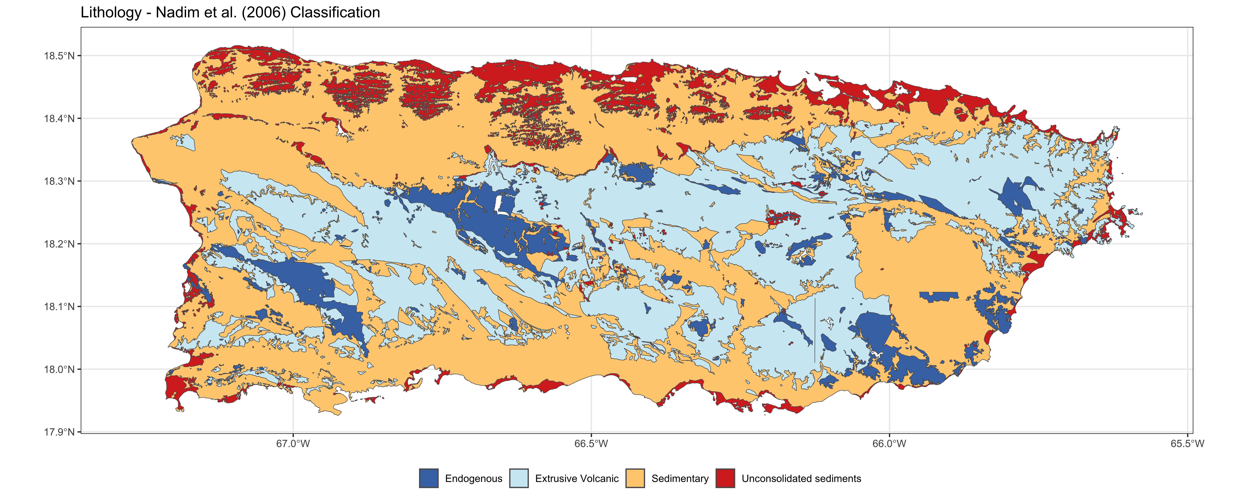

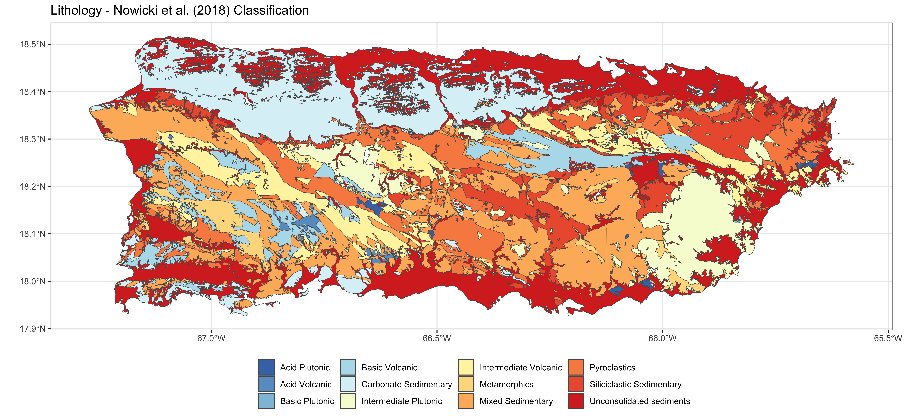

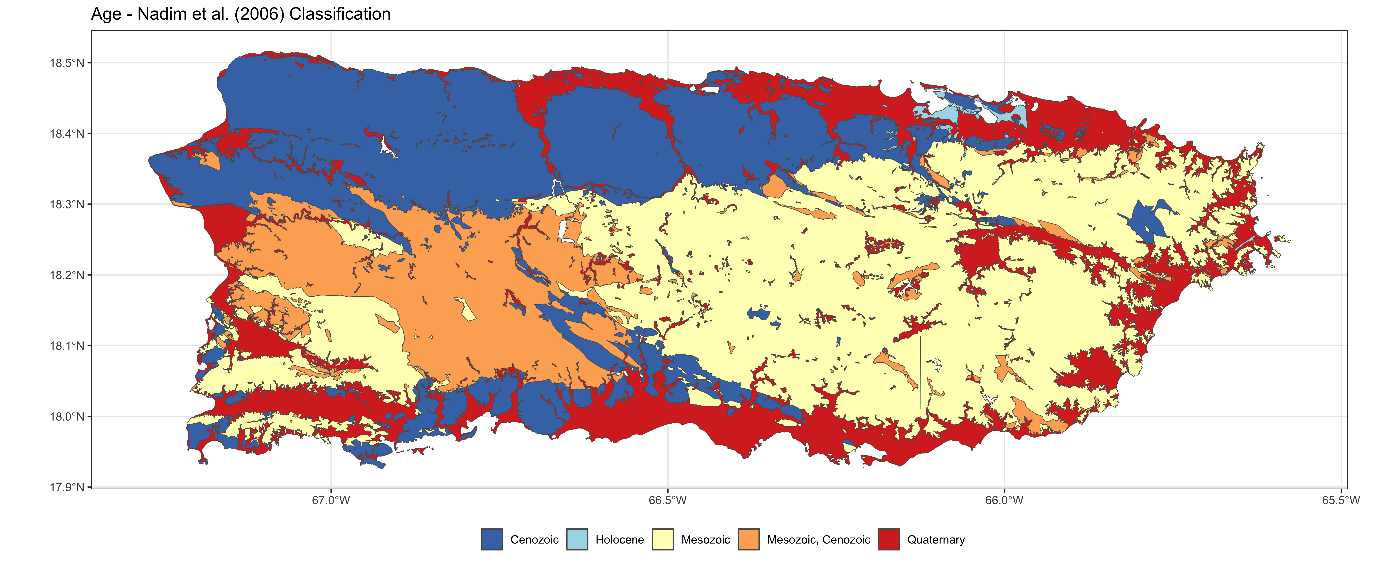

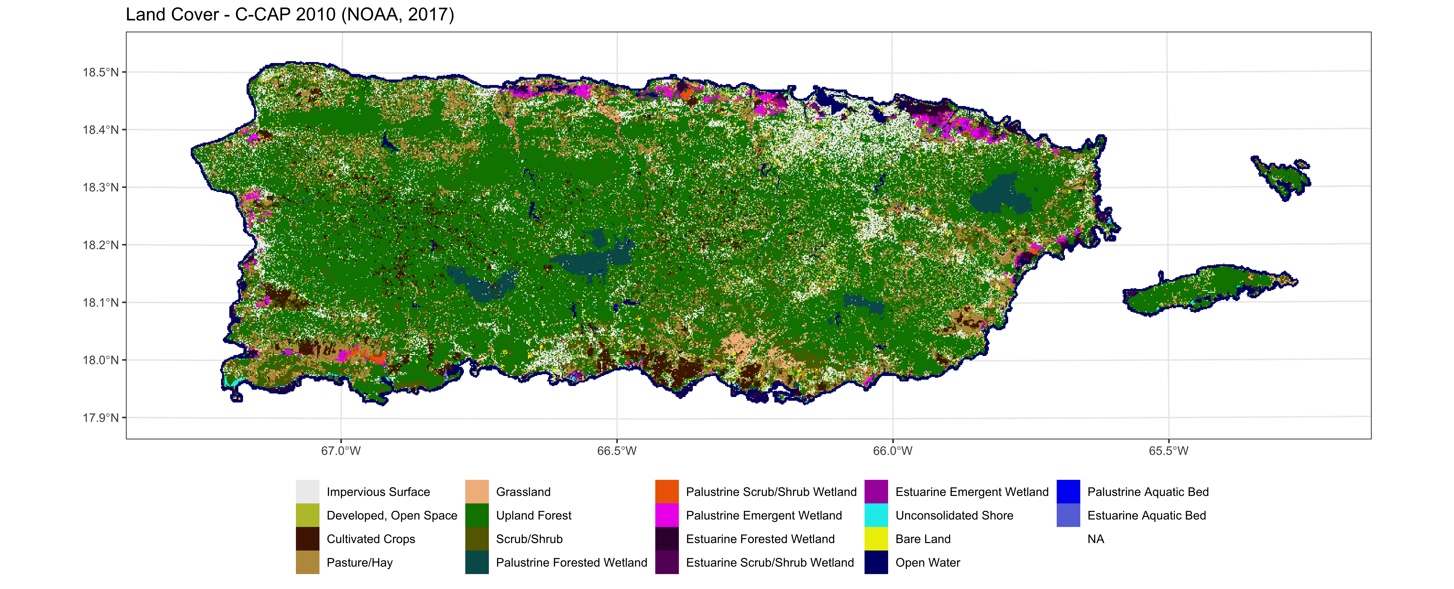

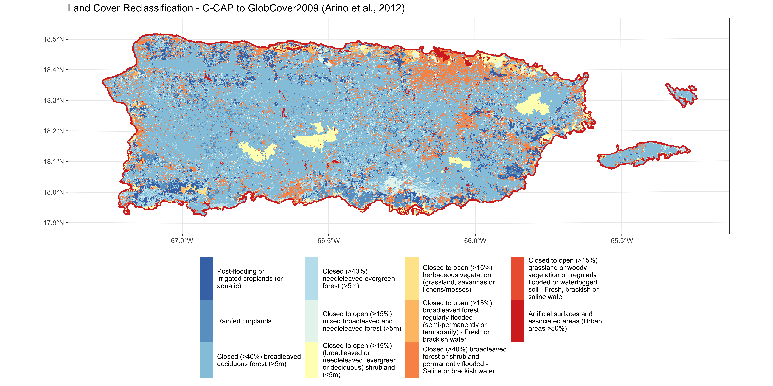

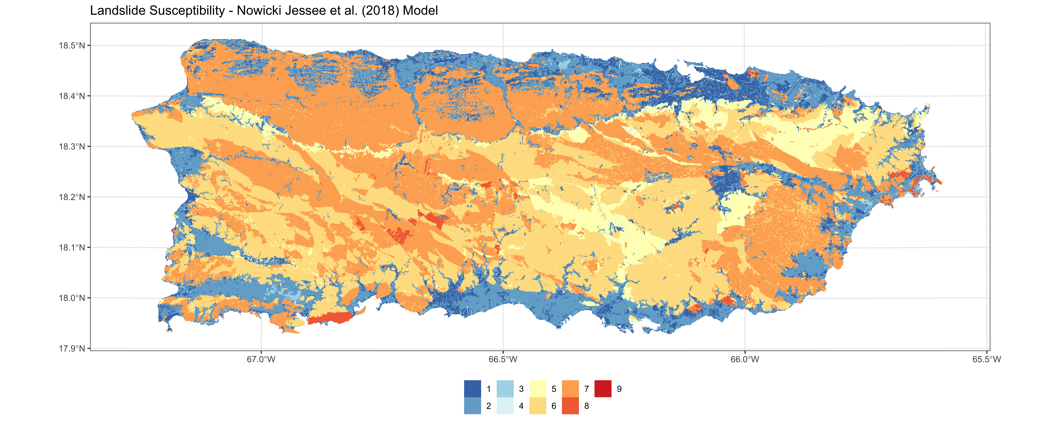

# References

(1998) [Geology, geochemistry, geophysics, mineral occurrences, and mineral resource assessment for the Commonwealth of Puerto Rico](https://pubs.usgs.gov/of/1998/of98-038/). Prepared in cooperation with the Puerto Rico Department of Natural Resources, University of Puerto Rico at Mayaguez

Arino O, Ramos Perez JJ, Kalogirou V, et al (2012) [Global Land Cover Map for 2009 (GlobCover 2009)](https://doi.org/10.1594/PANGAEA.787668). 40 data points

Atwater BF, Fuentes Z, Halley RB, et al (2014) Effects of 2010 Hurricane Earl amidst geologic evidence for greater overwash at Anegada, British Virgin Islands. Adv Geosci 38:21–30. <https://doi.org/10.5194/adgeo-38-21-2014>

Doser DI, Rodriguez CM, Flores C (2005) [Historical earthquakes of the Puerto Rico–Virgin Islands region (1915–1963)](https://doi.org/10.1130/0-8137-2385-X.103). In: Active Tectonics and Seismic Hazards of Puerto Rico, the Virgin Islands, and Offshore Areas. Geological Society of America

Fleming M, Hoffer R (1979) Machine processing of landsat MSS data and DMA topographic data for forest cover type mapping. Laboratory for Applications of Remote Sensing, Purdue University, West Lafayette, Indiana

Hartmann J, Moosdorf N (2012) The new global lithological map database GLiM: A representation of rock properties at the Earth surface. Geochem Geophys Geosyst 13:2012GC004370. <https://doi.org/10.1029/2012GC004370>

Hernangómez D (2023) Using the tidyverse with terra objects: The tidyterrapackage. JOSS 8:5751. <https://doi.org/10.21105/joss.05751>

Hijmans RJ (2023) [*Terra*: Spatial Data Analysis](https://CRAN.R-project.org/package=terra)

Hollister JW, (Ctb) ALR, (Rev) MWB, et al (2023) [*Elevatr*: Access Elevation Data from Various APIs](https://doi.org/10.5281/ZENODO.8335450)

Huérfano V (2003) Susceptibilidad de Puerto Rico ante el efecto de maremotos locales. PhD thesis, University of Puerto Rico-Mayagüez, Department of Marine Sciences

Mercado A, McCann W (1998) Numerical Simulation of the 1918 Puerto Rico Tsunami. Natural Hazards 18:57–76. <https://doi.org/10.1023/A:1008091910209>

Moore ID, Grayson RB, Ladson AR (1991) Digital terrain modelling: A review of hydrological, geomorphological, and biological applications. Hydrological Processes 5:3–30. <https://doi.org/10.1002/hyp.3360050103>

Nadim F, Kjekstad O, Peduzzi P, et al (2006) Global landslide and avalanche hotspots. Landslides 3:159–173. <https://doi.org/10.1007/s10346-006-0036-1>

NOAA, Office For Coastal Management [Coastal Change Analysis Program (C-CAP) Regional Land Cover 30 m Raster Dataset](https://www.coast.noaa.gov/htdata/raster1/landcover/bulkdownload/30m_lc/)

Nowicki Jessee MA, Hamburger MW, Allstadt K, et al (2018) A Global Empirical Model for Near‐Real‐Time Assessment of Seismically Induced Landslides. JGR Earth Surface 123:1835–1859. <https://doi.org/10.1029/2017JF004494>

O’Loughlin KF, Lander JF (2003) Caribbean tsunamis: A 500-year history from 1498-1998. Kluwer Academic Publishers, Dordrecht

QGIS Development Team (2024) QGIS Geographic Information System

R Core Team (2023) [*R*: A language and environment for statistical computing](http://www.Rproject. org/)

Ramírez-Rivera A (2016) Earthquake loss estimation in puerto rico from historical and potential earthquake scenarios. University of Puerto Rico-Mayagüez, Department of Geology

Tozer B, Sandwell DT, Smith WHF, et al (2019) Global Bathymetry and Topography at 15 Arc Sec: SRTM15+. Earth and Space Science 6:1847–1864. <https://doi.org/10.1029/2019EA000658>

Zahibo N, Pelinovsky E, Yalciner A, et al (2003) The 1867 Virgin Island tsunami: Observations and modeling. Oceanologica Acta 26:609–621. <https://doi.org/10.1016/S0399-1784(03)00059-8>